MYTHS FROM ANCIENT GREECE

The Argonautic Expedition

During the period of heroes and myths, the king of Iolkos, Aisonas, arrived on a dark night on mountain Pelion with his young son Jason. His brother, Pelias, had taken his throne and because he was afraid of his son’s life, he brought him to Pelion, in the cave of the Centaur Chiron.

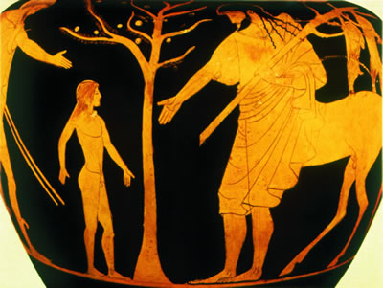

On the mountain of Pelion, there was a different kind of school whose teacher was the wise centaur Chiron. The lessons were given inside a big cave or in the forest near the cool springs. The pupils were the children of grand lords of Greece and studied there, away from their parents until they became 20 years old.

Jason grew up near Chiron and became a very bright and strong man. When he was 20, he decided to return to Iolkos to get back his father’s throne from Pelias. Along the way to Iolkos, he met an old woman on the side of the river who asked him to help her cross the river. She was Hera, the goddess, transformed as an old woman. She wanted to test his kindness. Jason, lifted her on his shoulders eagerly. But as he was crossing the river, he lost his sandal and went on to the town wearing one sandal only.

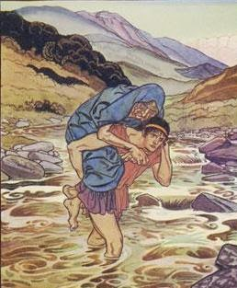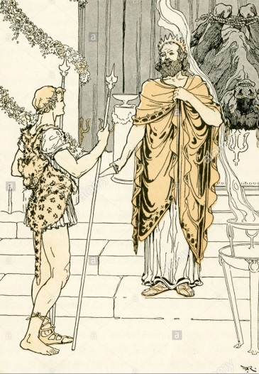

But his uncle Pelias, had been given an oracle by Delphi, saying this: “Fear the man wearing one sandal”. When the king saw the young man having one sandal only, he immediately knew who he was and got terrified. When Jason asked from Pelias his father’s throne, he told him that this could happen if he brought him the Golden Fleece from Colchis.

Jason accepted and he immediately ordered Argos-a fine technician-to build a strong ship with fifty oars. Hera helped to bring logs of pine trees from Pelion and with Athena’s help, Argos managed to make a very solid ship. Athena herself, nailed a piece of wood from the sacred tree of Zeus in Dodoni, which had human voice and could predict the future. The ship was named “Argo”.

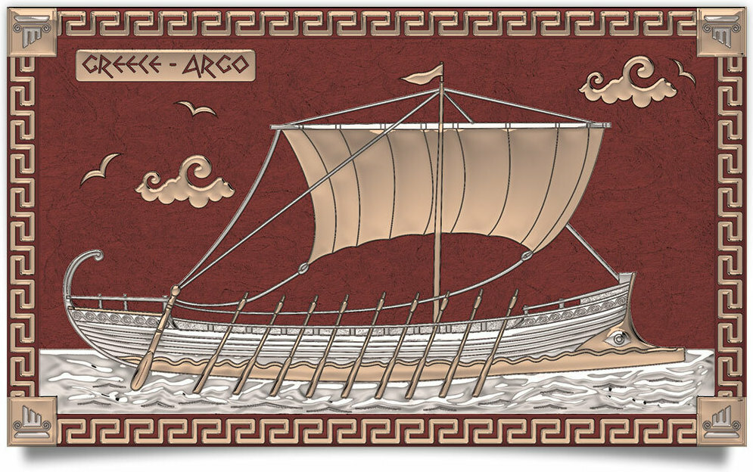

Fifty heroes from all over Greece, came to help and among them was Hercules, Theseus and the famous musician Orfeas. All these men were called “Argonauts”.

Travelling to Colchis, the Argonauts stopped in Thrace. There, they met Fineas, the blind foreseer. He told them about his suffering/ordeal. Every time he was about to eat, Harpies-monsters in the body of a bird, wings and the head of a woman- grabbed his food. He asked the Argonauts to help and save him from his torture. Zitis and Kalais, two of the Argonauts that were able to become winged and fly in the air really fast, went after the Harpies holding their arrows and made them promise not to bother the poor foreseer ever again.

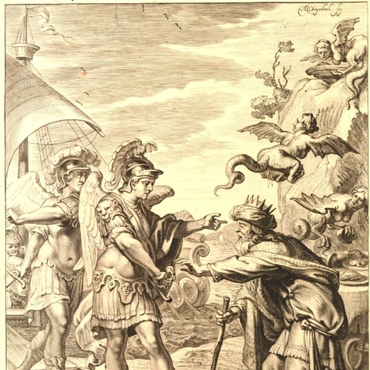

Then, Fineas told the Argonauts that they would come across Symlegades, known as Clashing Rocks. He advised them, before passing them through, to let a pigeon fly between the rocks. If the pigeon managed to pass through, then their ship, Argo, could manage to sail through as well.

Argo, after sailing the Aegean Sea and Hellispondos, finally reached the Clashing rocks. They were huge and high rocks that clashed unstoppably and faster than the wind. Thick fog was all over them and made a terrible noise. Not even a bird could fly through them. They destroyed every ship trying to sail through.
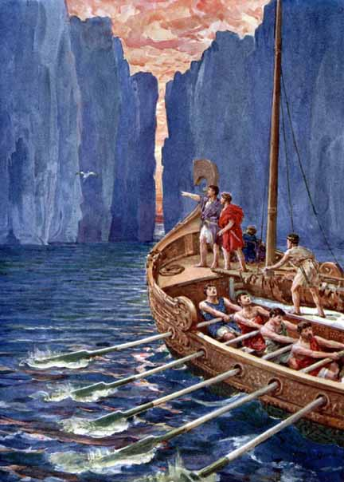

The Argonauts, following Phineas’ advice, let a pigeon fly through first so that they could see exactly how fast they had to row. And so it happened! The pigeon managed to fly through and only its tail feathers were caught by the rocks. Then, the Argonauts rowed quickly and with the help of Hera, they managed to get through losing only a part of the boat’s stern. After that, the Clashing Rocks stopped moving forever.

Travelling to the east, Argo finally reached Colchis. Jason presented himself in front of the king Aeetes (Eitis) and asked for the Golden Fleece. The king answered that he would give it to him if he managed to accomplish some difficult deeds. First, he had to tie two brazen footed bulls, puffing flames from their mouths, to plow a field with them, then to sow a dragon’s teeth in the field and finally kill the armed giants that would arise from the earth.

Jason accepted and Eitis’ daughter, Medea, who was a legendary witch, promised to help him. She gave Jason a magic ointment and with it he covered his body, his shield and his armor. In this way, he acquired tremendous power. Then, he managed to tie the wild bulls, he plowed the field and sowed the dragon’s teeth. Right away, armed giants came up from the earth and surrounded Jason. He immediately threw a huge stone among them as Medea had advised him. The giants then began to fight each other and soon they were all killed. After Jason’s deed, Medea found out that her father wasn’t intending to give Jason the Golden Fleece and on top of that he was planning to burn down his ship, Argo.

Then, Jason ordered his men to sit by the oars of the ship. When it got dark together with Medea and Orfeas, ran to the forest of god Aris, the god of war. At that time, Medea threw magic potion in the eyes of the dragon that guarded the fleece. Orfeas played his lyre melodiously and the dragon fell asleep. Immediately, Jason took the Golden Fleece. They all ran to the sea quickly, boarded on Argo and set sail to Colchis.

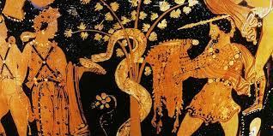

The trip back home was difficult and full of dangers. Jason married Medea and she always helped him using her magic. But some Gods were angry with them and made them lose their way and the storms drove the ship to various islands. So, they sailed by Corfu –the island of Faiakes-Peloponnese, Africa and Crete.

When they finally returned to Iolkos, Pelias didn’t keep his word and refused to pass the throne over to Jason. Then, Medea used her magic and managed to kill Pelias but because of that they had both to leave the place so they went together to Corinth. They dedicated Argo to Poseidon and decided to have races there in honor of the God. Jason often went and sat near his ship, Argo. Later, when he grew old a piece of wood fell from the ship and killed him.

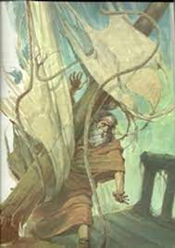

THE END

FAIRYTALE FROM OUR REGION

THE FISHERMAN AND HIS SWORD

Once upon a time there was a poor fisherman. He was so happy with his family that he used to have a glass of wine and to sing every afternoon in the backyard of his house.

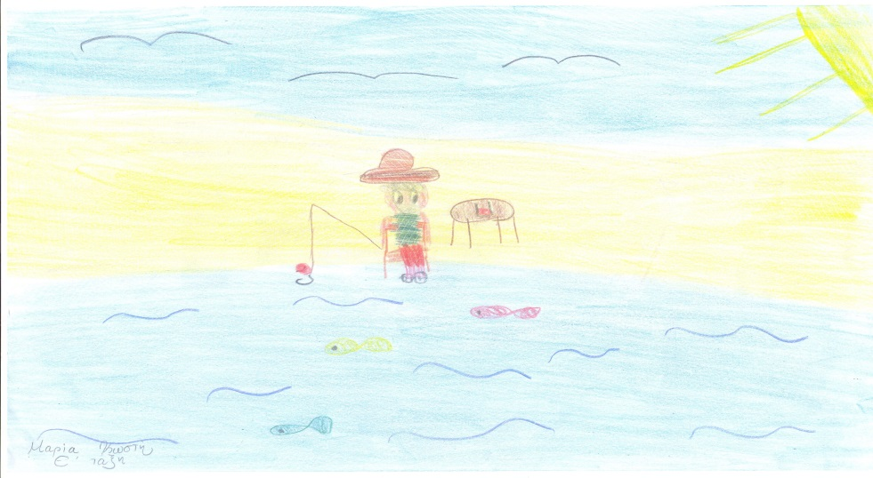

The lord of the region, who was walking near his house, was really curious how it was possible for such a poor man to be so happy.
His counselor, who was a bad and evil man, thought of a way to make the fisherman unhappy. He persuaded the lord to put a bag full of golden coins in the backyard of the fisherman’s house.
When the fisherman found it, his life really changed. Although he asked everyone to find out who had lost the golden coins, he found out that they didn’t belong to anyone. So he decided to keep them.

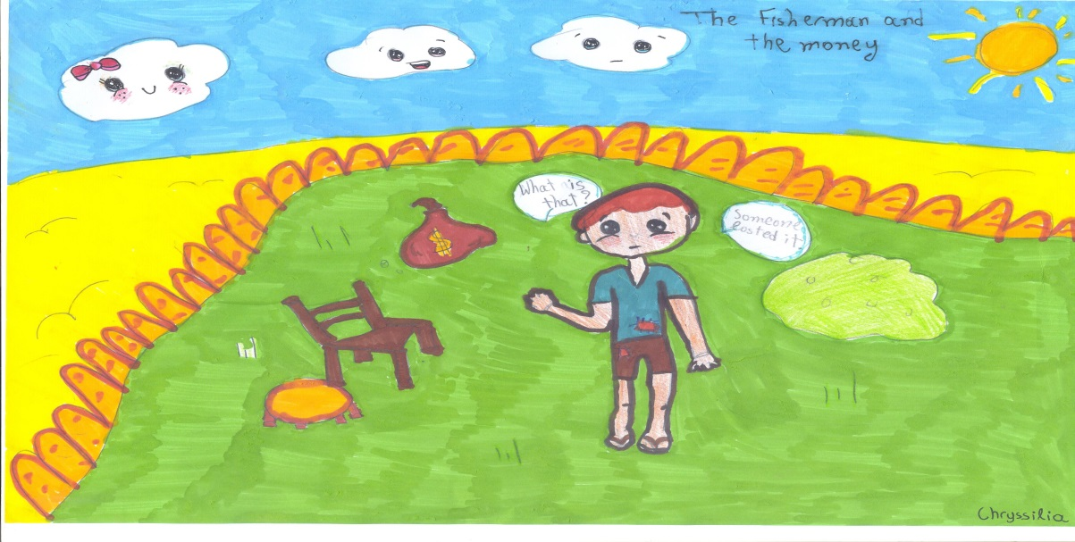

Then the members of his family, his relatives, his neighbors and his friends asked him for a lot favors or money because he was rich now. But he didn’t really know who he should help. His neighbors thought he was a mean man and stopped talking to him.

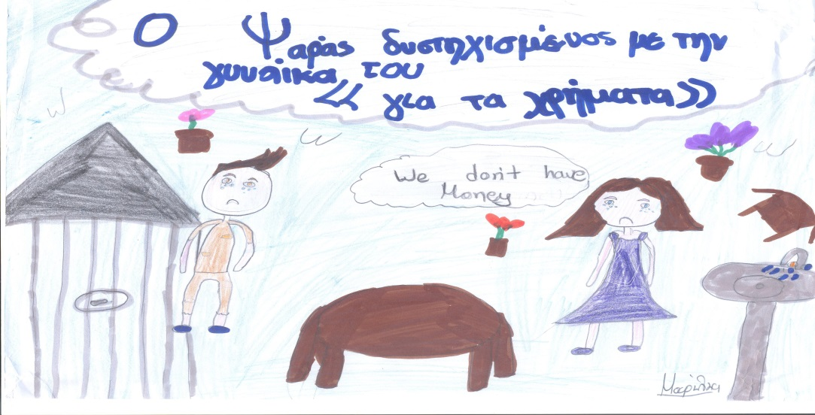

Unhappiness came into his life. What should he do with his little treasure? He stopped singing and having fun. At the end he realized what the cause of his unhappiness was and he decided to throw away his treasure. His life became happy again as it was before. He laughed and he had lots of fun.
But the evil counselor, who didn’t want anybody to be happy in this area, didn’t leave him alone. He convinced the lord of the region to call the poor fisherman and make him join the army, so that he would have new and bigger problems.
When the fisherman joined the army his family became unhappy. They didn’t have money to live. The lord had given the fisherman a sword with a diamond handle. After a lot of thought the fisherman decided to sell the precious sword in order to help his family with the money he would earn.
After a while, war broke out with the neighbors. The fisherman changed the real sword with a wooden one but of course it was impossible to fight with that.
The counselor understood what the fisherman had done and told it to the lord. So, some day the lord called the fisherman and ordered him to cut the head of a prisoner with sword.
The fisherman denied doing that but the lord insisted on that. So the fisherman, who was really clever, thought of a trick. He told everyone how cruel and bad was to kill somebody even if he was a prisoner. Then, looking up to the sky, he asked God to make his sword wooden, if he agreed with him.
Of course the wooden sword remained wooden, but everybody believed that God had agreed with him and so the fisherman won the confidence of the lord again and he lived happily with his family since then.

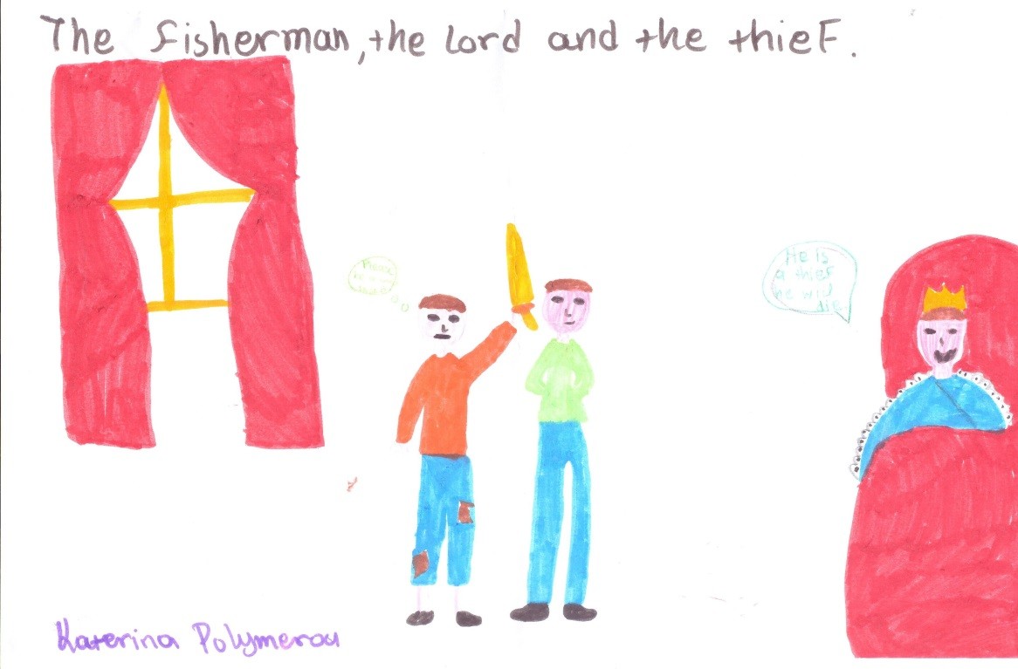

THE END

AISOP’S MYTHS

THE FOX AND THE STORK
Once upon a time, there lived in a jungle a cunning fox and a good natured stork. They both were neighbours.
One day, the fox thought of a naughty plan to entertain himself at the expense of the stork. He invited the stork to his house for dinner. The stork gladly accepted the invitation.
Next day, the stork arrived at the fox’s place for dinner with a good appetite. To her disappointment, the fox served soup on two flat plates.

The stork's beak was too long and pointy to eat the soup from the flat dish. All she could do was to wet the very tip of her beak, while the fox deliciously licked up all of the soup in his plate. Poor stork did not say anything and went home hungry that night.
One week later, the stork invited the fox for lunch at her place and he accepted the invitation. When the fox arrived, the stork served the lunch in two long thin necked jars.

This time the stork put her beak in the long thin necked jar and ate the delicious fish she prepared, but the fox could only lick at the rim of the jar and sniff at the delicious aroma. His wide snout couldn’t fit inside the thin necked jar. The fox had to go home hungry and humiliated this time.

Moral of the fox and the stork story
- Never make fun of other’s limitations.
- Treat others as you would have others treat you.
- People will treat you the same way you treat them

THE HARE AND THE TORTOISE

In a dense forest, a tortoise lived near a speedy hare. The hare was very proud of being very fast. He would often make fun of the tortoise for his slow pace. Tired of getting insulted, the tortoise challenged the hare for a race.
The hare laughed at the tortoise and said “A race? What a joke? I can beat anyone in this forest in a race.” The hare accepted the challenge and they decided to have the race on a fine sunny day.
On the day of the race, all the animals gathered to watch the race. The race started. The hare ran very fast and soon left the tortoise far behind.

On the way, the hare saw a place full of nice carrots. He looked back at the tortoise and saw that the tortoise was far behind him. He said “How does he expect to win the race when he is walking at such a slow pace?". He thought he had enough time to have some carrots. After having carrots he fell asleep thinking that he has plenty of time to relax.

Meanwhile, the tortoise walked and walked. He soon passed the hare and reached the finishing point.
The animals who were watching cheered so loudly for the tortoise that they woke up the hare.

The hare started running faster than he had ever run before. But he was too late. At the finishing line, he met the tortoise who was patiently awaiting his arrival.

Moral of the story
- Slow and steady wins the race.
- Keep trying even when things seem hard.
- You can be more successful by doing things slowly and steadily than by acting quickly and carelessly.
- Never underestimate others.
- Never be overconfident.

THE END

